Scouts and Parents -

The 2019 Troop charter was received and we have the new BSA ID cards for all registered scouts and leaders ready for distribution. This year we will be distributing the cards to scouts/parents upon confirmation that the Parent Volunteer Form has been completed and at least one member in the Scout family has registered for the BAND T66 group.

Parent volunteer form link - <https://goo.gl/forms/nbGc5sQsUQuzsAQE3>   or Scan QR code below

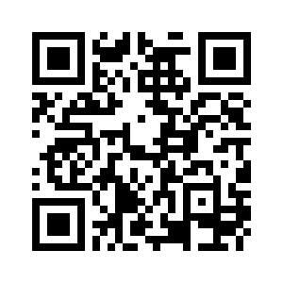

Join the Troop66 Edison, NJ group on BAND - <https://band.us/n/a7acz0J2T8L1Y>  or Scan QR code below



(Ideally we want the Scout and a parent or family member registered with the BAND group but we understand that not all scouts have access to a phone or are allowed to sign up for the service.  Note that you can use the band website too ([www.band.us](http://www.band.us/)) Please read the Troop email sent on 1/1 regarding the BAND app signup and check the BAND Parent letter in the Eagle’s Nest for more details.

All scouts should see Mr. Sapra to collect their 2019 BSA ID card and a collector's patch courtesy of the BAND app.  The Troop 66 committee has decided that you would need to have both the parent volunteer form completed **and** one family member registered with the BAND T66 group to pick up the ID card and patch.  Please check the scout list below to see your current status of the 2 tasks and please pick up your card if your name is color coded Green.  Yellow and Red coded names - if you need the BSA ID to register with the BAND app, this will be time to get it.  Please have the BAND app already installed and signed in so you can use the link above to enter the group and answer the question.

Gopi Sapra